Subnetting Scenario 1

- You have been given the following network topology and asked to assign appropriate addresses to the various hosts. The number of hosts for each LAN is displayed and includes the router interface as a host. You will need to assign two hosts to each link between routers (WAN link). You were originally told that you could only use the address space of 192.168.1.0 with a subnet mask of 255.255.255.0. You replied that you could not create enough fixed length subnets to meet the requirements. You were then given the additional address space of 192.168.2.0 with a subnet mask of 255.255.255.128 . Using both of these address spaces, complete a subnetting exercise and fill out the table on the next page.



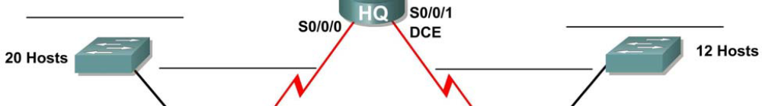

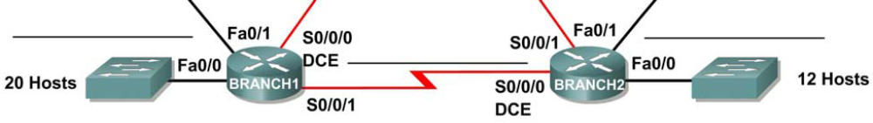

Subnet | Network Address | First Useable Host | Last Useable Host | Broadcast Address
Branch 1 – Fa0/0 – LAN
Branch 1 – Fa0/1 – LAN
HQ – Fa0/0 – LAN
HQ – Fa0/1 – LAN
Branch 2 – Fa0/0 – LAN
Branch 2 – Fa0/1 – LAN
Branch 1 – Branch 2 – WAN
Branch 1 – HQ – WAN
Branch 2 – HQ – WAN

- After completing the above table, you were then told that they really only wanted the one address space to be subnetted. For the same topology, fill in the below table after subnetting the address space 192.168.1.0 which has a subnet mask of 255.255.252.0 .

Subnet | Network Address | First Useable Host | Last Useable Host | Broadcast Address
Branch 1 – Fa0/0 – LAN
Branch 1 – Fa0/1 – LAN
HQ – Fa0/0 – LAN
HQ – Fa0/1 – LAN
Branch 2 – Fa0/0 – LAN
Branch 2 – Fa0/1 – LAN
Branch 1 – Branch 2 – WAN
Branch 1 – HQ – WAN
Branch 2 – HQ – WAN

